College of Micronesia-FSM

2020 Online Summits
Report

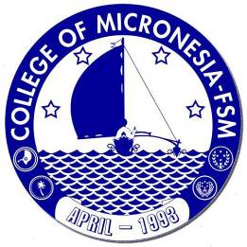

College of Micronesia-FSM
PO Box 159, Pohnpei, FM 96941

2020
VPIEQA, OIE

Table of Contents
1. Introduction 3
Online Summit for COM-FSM Participants 3
Online Mini-Summits for Community Stakeholders 3
2. Participants 4
3. Materials & Results 5
3.1. Institutional Check In 5
3.1.1. Mission review 6
3.1.2 Values review 8
3.1.3. Strategic Plan 2018 – 2023 Review 10
3.2. COVID-10 Preventive Measures | Training and Awareness 12
4. Appendix 14
4.1. Institutional Check-In Slides 14
4.2. Institutional Check-In Survey 23
4.3. COVID Preventive Measures Surveymonkey Quiz 35
4.4. Yap Mini Summit Minutes 43
4.5. Chuuk State Mini Summit Minutes 48
4.6. Kosrae State Mini Summit Minutes 52
4.7. Pohnpei State Mini Summit Minutes 57

Introduction

Online Summit for COM-FSM Participants

COM-FSM hosted its first Online Summit in August 2020. Aiming to give maximum flexibility to participants, summit materials were provided in advance allowing those who wanted to complete the work individually to do so. Some campuses and departments set up working groups, either online or socially distanced in-person, to bring together those who preferred to work in groups. There were two components: COM-FSM Institutional Check-In, and training on “COVID-19 Preventive Measures & Framework”.

On August 4th from 9am, a Collegewide Zoom Coffee room was available for anyone who wished to see who was around to 'bump into', have a chat, share a moment. There was no facilitator, no agenda, no obligation - there for anyone who wants to bump into anyone else who was in there at the time. 34 people joined the coffee room that day.

The “Institutional Check In” is part of the Strategic Planning cycle. This component, titled “How Does My Daily Work At COM-FSM Connect With the Bigger Picture?” asked participants to share their thoughtful, honest inputs on how COM-FSM is doing. The targeted outcomes for participants were:

1) An awareness of some basic facts about the College of Micronesia-FSM
2) Reflection on the Purposes of COM-FSM
3) Review of COM-FSM Mission, Mission Fulfillment Indicators and Values
4) Progress towards Strategic Plan 2018-2023 –> action plans

The second component, “COVID-19 Preventive Measures & Framework: Training & Awareness” aimed for the following three outcomes.

1) An awareness and basic understanding of COM-FSM's COVID-19 Preventive Measures & Framework document
2) Demonstrate an understanding of the different conditions of readiness across FSM
3) Understand best practices around wearing and cleaning face-masks

Online Mini-Summits for Community Stakeholders

COM-FSM Mission & Values Review: Are We Living Up To Our Mission?

A mini-summit for each of the four States was held for community members online to review the college mission statement, the extent to which we are achieving it, and consider recommendations to improve.
During the summits, participants reviewed 24 mission fulfillment indicators.

Participants

The table below shows the number of participants by campus for the two components of COM-FSM’s online summit, August 4th 2020

 | Institutional Check In | COVID-19 Training & Awareness
Chuuk | 47 | 38
CTEC | 53 | 40
FSM-FMI | 13 | 9
Kosrae | 29 | 25
National | 107 | 89
Yap | 33 | 34
TOTAL | 282 | 235
Table 1: Number of participants by campus for the two components of COM-FSM’s online summit, August 4th 2020
Next, we see the participants in each of the State’s mini-summits, hosted online during October and early November 2020.

State | Date & Time | Participants | Including…
Yap | 10/27/20  2pm - 3:30pm | 18 | - Senator, Yap State Legislature Member of Resources, Education Dev. Committee  - Early Childhood Education Coordinator  - Special Education Coordinator  - Chief Nurse, Health Services  - Director, Resources & Development  - Yap Cooperative Association  - Department of Education Staff  - Principal, Yap High School  - Director, Health Services,  - Principal, Yap Catholic High School  - Acting Director, Department of Education  - State Public Auditor  - Department of Education, Curriculum Division  - Department of Education, Staff  - Senator, floor leader  - Department of Education, Watch School Administration  - COM-FSM Yap Campus Dean  - COM-FSM VPIEQA
Chuuk | 10/28/20  2pm – 3:30pm | 8 | - Chief Justice, Chuuk State Supreme Court  - Representative, Chuuk State Legislature House of Representatives  - Executive Director, CSSS  - Chief of Public Health  - Principal, Saramen Chuuk Academy  - Director, Small Business Development Center  - COM-FSM Chuuk Campus Dean  - COM-FSM VPIEQA
Kosrae | 10/29/20  2pm – 3pm | 8 | - Kosrae State Scholarship Administration  - Division of Agriculture & Land Management  - DOE  - COM-FSM Kosrae Campus Dean  - COM-FSM VPIEQA
Pohnpei | 11/05/20  3pm – 4:30pm | 4 | - Congress  - FSM Development Bank  - COM-FSM CTEC Campus Dean  - COM-FSM VPIEQA
Table 2: Participants in Community Stakeholders' State Mini-Summits 2020

Materials & Results

3.1. Institutional Check In

The “Institutional Check In” is part of the Strategic Planning cycle. This component, titled “How Does My Daily Work At COM-FSM Connect With the Bigger Picture?” asked participants to share their thoughtful, honest inputs on how COM-FSM is doing. The targeted outcomes for participants were:

1) An awareness of some basic facts about the College of Micronesia-FSM
2) Reflection on the Purposes of COM-FSM
3) Review of COM-FSM Mission, Mission Fulfillment Indicators and Values
4) Progress towards Strategic Plan 2018-2023 –> action plans

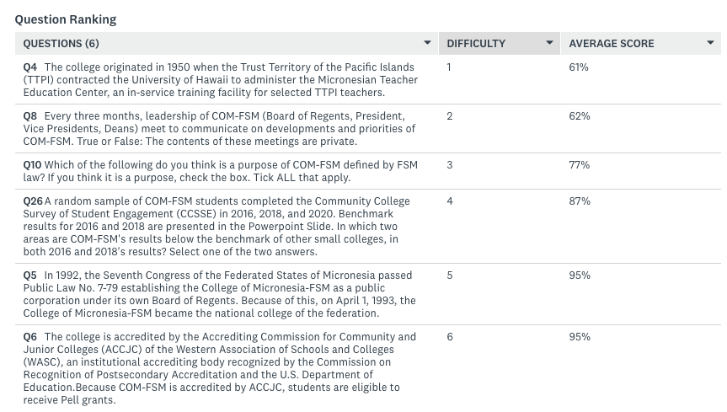

- Many among the college community think the content of Board meetings is confidential, despite board reports, agendas, and minutes being published online.
- Though “Maintaining accreditation by ACCJC” is listed in FSM law as the second purpose of COM-FSM, many do not recognize this as a purpose.

3.1.1. Mission review

College community members know the mission statement well.

- The broad educational purpose of the college to be to provide academic and career and technical education programs characterized by continuous improvement and best practices”

- The intended student population is recognized as FSM students and citizens as well as diverse groups in the community

- People understand that the types of degrees and credentials that COM-FSM offers are AA, AS, AAS, BS, and certificates. Some people answered “Degree and Certificates in academic and career and technical education programs” while others specified the programs available at their respective campuses.

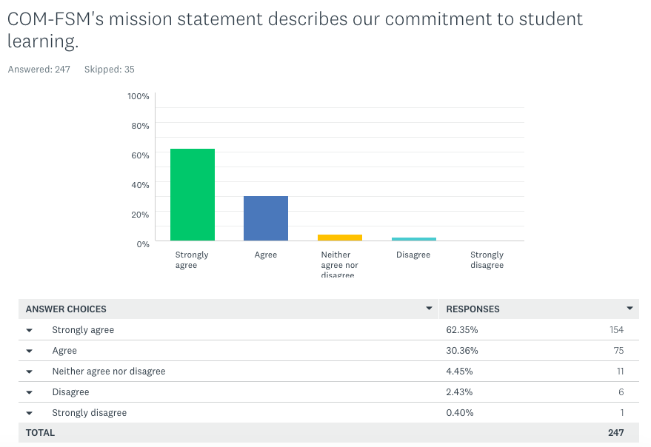

Open comments on the above question included:

- The college is viewed as an ideal institution for best practices demonstrated through excellence, fineness and honesty of both employees and graduates.
- Based on external rumors, quality of our students are direct results of the high school they come from
- It only describes the commitment to the success of the FSM, but not student learning
- We might do more to strengthen existing cultures, eg. preventing language loss by creating pathways for scholarly and study of local indigenous languages. Language arts instruction in local language ends at elementary level here. This is of significant concern among community colleges in Native American communities on the US mainland.
- Implicit: only in the phrase “learner-centered”
- May not always have sufficient resources
- Learner-centered is the same as commitment to student learning

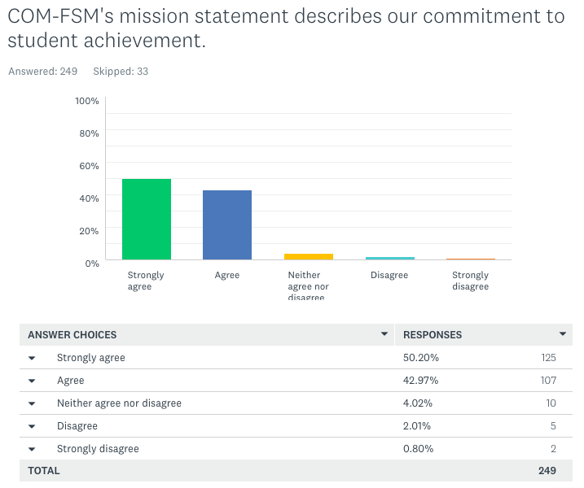

3.1.2 Values review

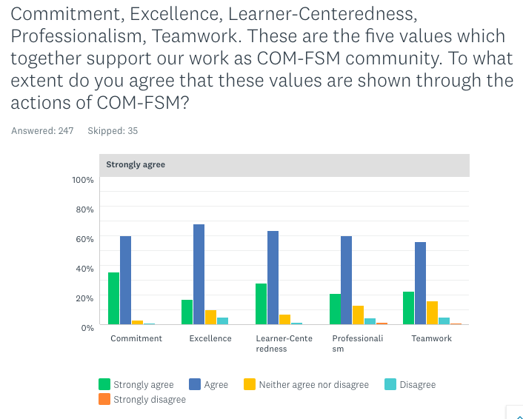

Open comments to the above question included:
- I strongly agree that these are what we do with the college
- Honesty to oneself is essential to achieving greatness and beyond. Unless one is willing to consider his limitation and admit his needs of commitment, excellence, professionalism and teamwork, he won’t be able to develop beyond his own standard.
- Personally I do witness lack of professionalism among the staff
- Need more cooperation between campuses
- I think there ought to be Creativity and Flexibility added
- The college can be more professional and excellent if the college administration can accept input from college community and stakeholders. There is insufficient focus on student learning and training of faculty and staff.
- Relationships between national campus and state campuses is poor
- In my observation, the college is operating in small units instead of a whole. Each department perceive their roles as a unit instead of embracing and operating for the success of the college as a whole.
- The college needs to put more attention on employees, by acknowledging their areas of need. Many times, employees feel that their needs are not heard or felt by the college. At least internally, the college should be staff-centered.
- So far COM-FSM is doing well and working hard for students’ success
- Some faculty strive for excellence, others just doing their job.
- Employees need to be reminded of these core values, and hospitable towards one another. Interpersonal skills are very important.
- There is always room for improvement

3.1.3. Strategic Plan 2018 – 2023 Review

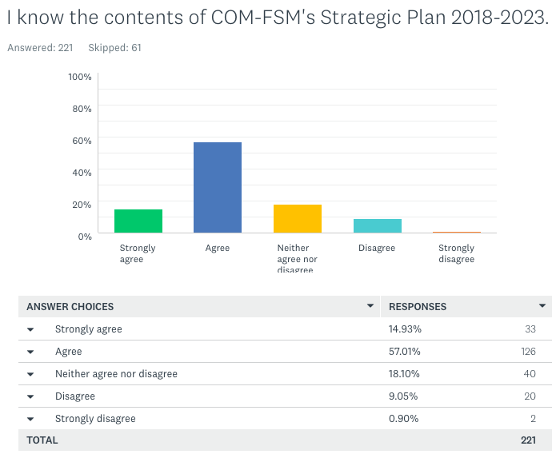

Detailed review of the questions regarding the Strategic Plan 2018-2023 will be provided in the Strategic Plan 2018-2023 mid-term report.

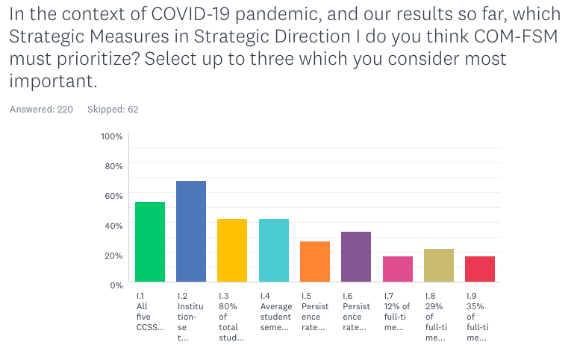
68% of people believe that the most important Strategic Direction to focus on is 1.2 – Institutional Set Standards are met. Next, 54% want to focus on meeting CCSSE five benchmarks.

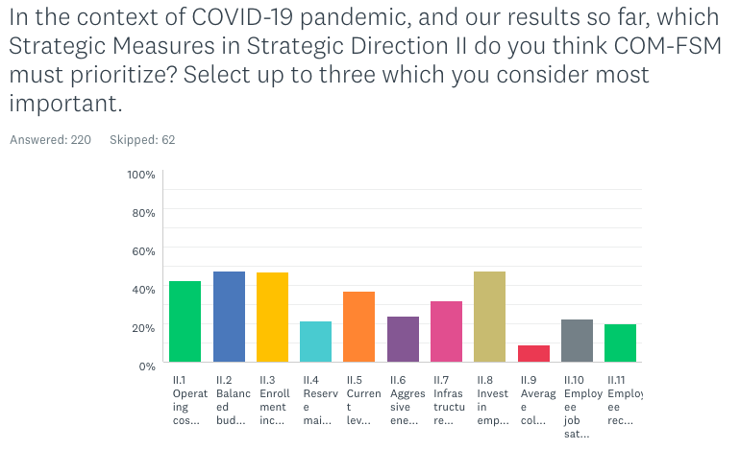
Within Strategic Direction II, the top three priorities are:
- II.8, Invest in employee development and capacity building to improve practices
- II.2 Balance budget maintained
- Enrollment increased by 5%

3.2. COVID-10 Preventive Measures | Training and Awareness

In addition to the document, Appendix G COVID-19 Preventive Measures & Framework (adopted by the EMT on 07/22/20 and added to COM-FSM’s Emergency Management Plan), a short video was created and made available on COM-FSM’s official YouTube channel.

Participants were asked questions using a SurveyMonkey quiz, which provided immediate feedback on correct and incorrect answers. Results from qualitative questions will be used to help people clarify unclear issues within their departments and also identify any points in the document that may need revisions. The complete surveymonkey quiz can be found in the appendix. Feedback, including correct answers and explanations, was provided immediately to participants upon survey completion.

The table below shows that the most difficult question was the question about the four conditions of readiness across FSM. One of the main goals in the training was to raise awareness of these levels and what they meant. Five more questions aimed to deepen understanding of the different scenarios possible under the different conditions of readiness.

The message of limiting gathering to no more than 10 people was generally well understood, as is the rule of social distancing – keeping at least 6 feet apart.

The college EMT made the decision to make the wearing of masks on all campuses mandatory under condition 4. The aim of this is to help educate people and train them in the practices associated with preventing COVID-19, before the virus reaches the islands. With mask-wearing being unfamiliar in FSM, open questions were posed to get people thinking about why some people do want to wear masks while others do not. Then, best practices (as defined by WHO) associated with mask-wearing were introduced.

94.52% of participants strongly agreed or agreed that they had learnt about COM-FSM’s Preventive Measures and Framework from the online summit training.

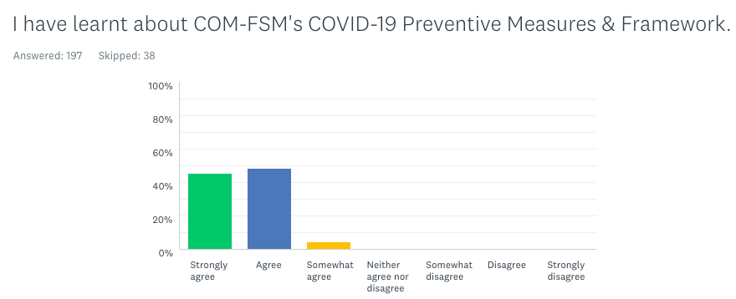
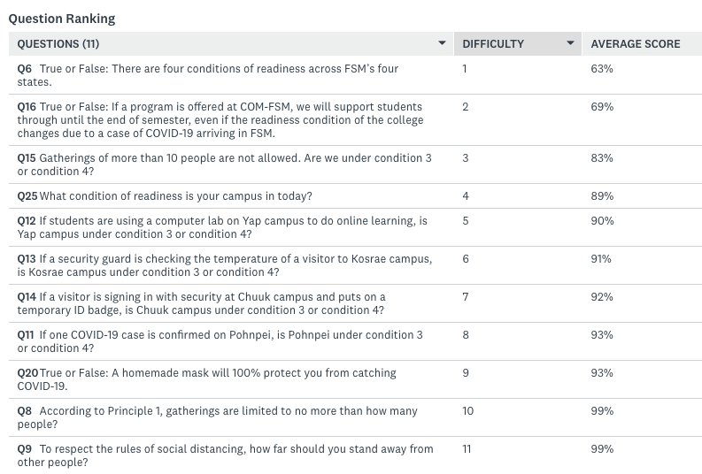

Appendix

4.1. Institutional Check-In Slides

4.2. Institutional Check-In Survey

COM-FSM - the basics
Before setting sail on any journey, it's important to look back to know where you came from. The history of the College of Micronesia-FSM (COM-FSM) reflects the growth of the Federated States of Micronesia as a nation. What do you know about our history?
1. Your name

  - 2. Campus
Chuuk CTEC FSM-FMI
Other (please specify)

  - 3. Which Vice President is your department under?
VPAS VPEMSS
VPIA

Kosrae National Yap

VPIEQA
I'm not sure

  - 4. The college originated in 1950 when the Trust Territory of the Pacific Islands (TTPI) contracted the University of Hawaii to administer the Micronesian Teacher Education Center, an in-service training facility for selected TTPI teachers.
True False

  - 5. In 1992, the Seventh Congress of the Federated States of Micronesia passed Public Law No. 7-79 establishing the College of Micronesia-FSM as a public corporation under its own Board of Regents. Because of this, on April 1, 1993, the College of Micronesia-FSM became the national college of the federation.
True False

  - 6. The college is accredited by the Accrediting Commission for Community and Junior Colleges (ACCJC) of the Western Association of Schools and Colleges (WASC), an institutional accrediting body recognized by the Commission on Recognition of Postsecondary Accreditation and the U.S. Department of Education.

Because COM-FSM is accredited by ACCJC, students are eligible to receive Pell grants.
True False

- 7. Who is the Dean responsible for the campus where you work?

If you work at National campus, can you name the Dean of Academic Programs?

  - 8. Every three months, leadership of COM-FSM (Board of Regents, President, Vice Presidents, Deans) meet to communicate on developments and priorities of COM-FSM.

True or False: The contents of these meetings are private.
True False

What are we doing here?
What is the purpose of COM-FSM? When was the last time you stopped to think about why the college exists?

The FSM Constitution (article 13, Section 1) states:
The national government of the Federated States of Micronesia recognizes the right of the people to education, health care, and legal services and shall take every step reasonable and necessary to provide these services.

Link to FSM law, constitution, article XIII

- 9. Purpose = the reason for which something is done or created or for which something exists.

In your view, what is the purpose of COM-FSM?
Why does the college exist?

Write your ideas here - there are no right or wrong answers!

10. Which of the following do you think is a purpose of COM-FSM defined by FSM law?
If you think it is a purpose, check the box.

Tick ALL that apply.
Provide for such services as post-secondary education instruction, teacher training, continuing education, cultural education, adult basic education, vocational education, extension services, post-high school college preparatory instruction and assistance, administration of post- secondary education financial assistance programs for students attending COMFSM, monitoring COMFSM student performance, and other post-secondary education related functions;
Maintain accreditation by the Western Association of Schools and Colleges and other appropriate accreditation institutions;

Develop and offer certificate and degree programs in fields that will meet the development and manpower needs of the States and Nation;

Assist, when requested, in any training and education programs and services currently being provided to adults and out-of-school youths by various public and private agencies and organizations;

Develop and conduct outreach programs where there is an established need and available funding;

Serve as an instruction, research and extension site for Land Grant Programs for COM and/or COMFSM, be eligible to receive funding, endowments and interest available to Land Grant institutions, and provide instruction, training, coordination, assistance and financial and other support for Land Grant Programs;
Coordinate with other educational institutions in the Micronesian region and other locations, for such matters as the transfer of credits and programs, reciprocal treatment of students for immigration, work-study, and other purposes, coordination of exchange programs, joint and cooperative research or educational programs, and such other matters that deal with the cooperative interaction between COMFSM and other educational institutions;

Coordinate and cooperate with the respective education departments in each of the States and with the National Government Department of Human Resources, Division of Education, for the effective shared use of resources, including, but not limited to, facilities, equipment, personnel, technical assistance, funding, and educational support services;
Conduct and support research relevant to the needs of the States and the National Government of the Federated States of Micronesia to the degree funding is available particularly as relevant to assessing ongoing training, educational, and technological needs;
Administer, coordinate, and provide services related to post-secondary student financial assistance provided by governmental and other sources for students attending COMFSM and other affiliated programs;

Serve as a post-secondary education testing center;

Support and fund continuing education centers and/or other equivalent programs in the States;

Upon specific request, serve as an assisting and coordinating agency for all post-secondary education activities conducted within the Federated States of Micronesia when requested by other agencies and organizations;
Provide other post-secondary and adult education related activities as determined by the Board and as financially feasible.

Any comments on these purposes?

COM-FSM Mission & Values
COM-FSM's mission provides a framework for all institutional goals and activities. Let's take a closer look....
- 11. What is COM-FSM's mission statement?

- 12. According to COM-FSM's mission statement, what is/are our broad educational purpose(s)?

- 13. According to COM-FSM's mission statement, who are our intended student population?

- 14. According to COM-FSM's mission statement, what types of degree and credentials do we offer?

- COM-FSM's mission statement describes our commitment to student learning.

Strongly agree Agree
Neither agree nor disagree

Disagree Strongly disagree

Any comments?

- COM-FSM's mission statement describes our commitment to student achievement.

Strongly agree Agree
Neither agree nor disagree

Disagree Strongly disagree

- 17. COM-FSM uses various measures to evaluate whether we are achieving our mission. Click here and scroll down the page to find the table "COM-FSM Status of Mission Indicators".

Name one measure of success which was achieved in 2020. (Measures achieved are shown in green)

- COM-FSM uses various measures to evaluate whether we are achieving our mission. Click here and scroll down the page to find the table "COM-FSM Status of Mission Indicators".

Name one measure of success which was NOT achieved in 2020. (Measures not achieved are shown in red)

- Considering the data and your own understanding, which area is COM-FSM doing well in?

- Considering the data and your own understanding, which area is COM-FSM not doing well in?

- Commitment, Excellence, Learner-Centeredness, Professionalism, Teamwork. These are the five values which together support our work as COM-FSM community.

To what extent do you agree that these values are shown through the actions of COM-FSM?





Strongly agree
Commitment Excellence
Learner-Centeredness Professionalism
Teamwork
Any comments?

COM-FSM Strategic Plan 2018-2023
COM-FSM's Strategic Plan 2018-2023 has two strategic directions and 20 measures of success.

How does your daily work connect to the overall goals of the College?

* 22. I know the contents of COM-FSM's Strategic Plan 2018-2023.

Strongly agree Agree
Neither agree nor disagree

Disagree Strongly disagree

- 23. In no more than 30-seconds, try to find COM-FSM's Strategic Plan 2018-2023 on http://www.comfsm.fm/ Paste the link below.

24. I know how my daily work tasks connect to COM-FSM's Strategic Plan 2018-2023.

Strongly agree Agree
Somewhat agree
Neither agree nor disagree
Somewhat disagree Disagree
Strongly disagree

25. Strategic Direction I: Innovate academic quality to ensure student success.

Ensure student success by decreasing time to completion and increasing student satisfaction, persistence, retention, and graduation rates by innovating academic quality and enhancing student support services.

Below are the nine measures of success for strategic direction I.

Which measures do you feel your daily work directly contributes to achieving?

Check all that apply.
All of them

  - All five CCSSE benchmarks are exceeded.

  - Institution-set Standards are met.

  - 80% of total students are enrolled full time.

  - Average student semester credits earned is 12.

  - Persistence rate (fall to spring) is 95%.

  - Persistence rate (fall to fall) is 80%.

  - 12% of full-time students graduate within one year.

  - 29% of full-time students graduate within two years.

  - 35% of full-time students graduate within three years None of them
I don't know

Any comments?

  - 26. A random sample of COM-FSM students completed the Community College Survey of Student Engagement (CCSSE) in 2016, 2018, and 2020. Benchmark results for 2016 and 2018 are presented in the PowerPoint Slide.

In which two areas are COM-FSM's results below the benchmark of other small colleges, in both 2016 and 2018's results? Select one of the two answers.

Active and Collaborative Learning Student Effort
Academic Challenge
Student-Faculty Interaction Support for Learners

  - 27. Look at "Measure of Success I.2 Institution-Set Standards are met" PowerPoint slide. The results show an overview of results from 2015-2020.

Considering the data and your own understanding, which academic year was COM-FSM most successful?

2015-2016
2016-2017
2017-2018
2018-2019
2019-2020

Any comments? What do you learn from the information provided?

- 28. Look at "Measure of Success I.6 Persistence Rate (Fall to Fall) is 80%" PowerPoint slide.

What do you notice about the percentage of students who are continuing their studies from one fall semester to the next year at your campus? What comments do you have on this strategic measure and our results so far?

29. Strategic Direction II: Strengthen resources to meet current and future needs.

Strengthen resources to meet current and future needs through revenue diversification, efficient use, innovation, effective allocation, conservation, infrastructure upgrades, and
investment in human capital.

Below are the 11 measures of success for strategic direction II.

Which measures do you feel your daily work directly contributes to achieving?

Check all that apply.
All of them

  - Operating costs reduced by 5% by innovating and streamlining services and processes.

  - Balanced budget maintained.

  - Enrollment increased by 5%.

  - Reserve maintained at 40%.

  - Current levels of government financial support are annually maintained or exceeded.

  - Aggressive energy conservation measures in place reducing total annual cost by 20%.

  - Infrastructure upgraded in accordance with Phase I of the Facilities Master Plan

  - Invest in employee development and capacity building to improve practices.

  - Average college employee attrition rate is less than 5% annually.

  - Employee job satisfaction survey yields overall 85% Satisfaction Rate.

  - Employee recruitment process is revamped to significantly reduce time from recruitment to hiring.

None of them I don't know

- 30. Look at "Measure of Success II.1 Operating costs reduced by 5% by innovating and streamlining services and processes" PowerPoint slide.

What do you notice about the total operating costs between 2016-2018. What comments do you have on this strategic measure and our results so far?

- 31. Look at "Measure of Success II.3 Enrollment increased by 5%" PowerPoint slide. The results show an overview of results from 2015-2020.

What do you notice about the enrollment trends at your campus? What comments do you have on this strategic measure and our results so far?

- 32. Look at "Measure of Success II.6 Aggressive energy conservation measures in place reducing total annual cost by 20%" PowerPoint slide.

What do you notice about COM-FSM's electricity consumption? What comments do you have on this strategic measure and our results so far?

- 33. Look at "Measure of Success II.7 Infrastructure upgraded in accordance with Phase I of the Facilities Master Plan" PowerPoint slide.

What do you notice about implementation of COM-FSM's Infrastructure Development Plan? What comments do you have on this strategic measure and our results so far?

  - 34. In the context of COVID-19 pandemic, and our results so far, which Strategic Measures in Strategic Direction I do you think COM-FSM must prioritize? Select up to three which you consider most important.

  - All five CCSSE benchmarks are exceeded.

  - Institution-set Standards are met.

  - 80% of total students are enrolled full time

  - Average student semester credits earned is 12.

  - Persistence rate (fall to spring) is 95%.
  - Persistence rate (fall to fall) is 80%.

  - 12% of full-time students graduate within one year.

  - 29% of full-time students graduate within two years.

  - 35% of full-time students graduate within three years

Other (please specify)

35. In the context of COVID-19 pandemic, and our results so far, which Strategic Measures in Strategic Direction II do you think COM-FSM must prioritize? Select up to three which you consider most important.

  - Operating costs reduced by 5% by innovating and streamlining services and processes.

  - Balanced budget maintained.

  - Enrollment increased by 5%.

  - Reserve maintained at 40%.

  - Current levels of government financial support are annually maintained or exceeded.

  - Aggressive energy conservation measures in place reducing total annual cost by 20%.
  - Infrastructure upgraded in accordance with Phase I of the Facilities Master
Plan

  - Invest in employee development and capacity building to improve practices

  - Average college employee attrition rate is less than 5% annually.

  - Employee job satisfaction survey yields overall 85% Satisfaction Rate.

  - Employee recruitment process is revamped to significantly reduce time from recruitment to hiring.

Other (please specify)

4.3. COVID Preventive Measures Surveymonkey Quiz

Get to know COM-FSM’s COVID-19 Preventive Measures & Framework

COVID-19 Preventive Measures | Training & Awareness
Welcome to the most exciting surveymonkey survey ever (possibly). You can make it more exciting by playing music in the background, timing how long it takes you to complete, or accepting your colleagues' bribes to complete the training on their behalf (recommended bribery $20 per survey).

Refer to the YouTube video and the COM-FSM Preventive Measures document to help you answer the questions.

Some of the answers to the questions can be found in the video, some in the document. All questions ask you to think and respond. Do your best!
Your answers will be used to assess how clear and useful the information provided in the document is and to identify any points which have not yet been addressed. We are all learning together – preventing COVID-19’s arrival or spread across COM-FSM is our shared responsibility.
- 1. Your name

  - 2. Campus
Chuuk CTEC FSM-FMI

  - 3. Which Vice President is your department under?
VPAS VPEMSS
VPIA

Kosrae National Yap

VPIEQA
I'm not sure

4. Oh no! It looks like I'm being asked to do ANOTHER survey online. I'd prefer to be doing something else right now.

Strongly agree Agree
Neither agree nor disagree
Disagree Strongly disagree

5. Why was the COVID-19 Preventive Measures document made?

  - 6. True or False: There are four conditions of readiness across FSM’s four states.
True False

- 7. What will cause the change from condition 4 to condition 3?

  - 8. According to Principle 1, gatherings are limited to no more than how many people?
5 11
9 20
10

  - 9. To respect the rules of social distancing, how far should you stand away from other people?
2 feet
3 feet
6 feet or more

- 10. If you are sick or taking care of someone who is sick, where should you stay?

  - 11. If one COVID-19 case is confirmed on Pohnpei, is Pohnpei under condition 3 or condition 4?
Condition 3
Condition 4

  - 12. If students are using a computer lab on Yap campus to do online learning, is Yap campus under condition 3 or condition 4?
Condition 3
Condition 4

  - 13. If a security guard is checking the temperature of a visitor to Kosrae campus, is Kosrae campus under condition 3 or condition 4?
Condition 3
Condition 4

  - 14. If a visitor is signing in with security at Chuuk campus and puts on a temporary ID badge, is Chuuk campus under condition 3 or condition 4?
Condition 3
Condition 4

  - 15. Gatherings of more than 10 people are not allowed. Are we under condition 3 or condition 4?
Condition 3
Condition 4

  - 16. True or False: If a program is offered at COM-FSM, we will support students through until the end of semester, even if the readiness condition of the college changes due to a case of COVID-19 arriving in FSM.
True False

- From Friday March 20th 2020 until Tuesday April 21st 2020, all COM-FSM campuses were closed with a restricted area imposed around those living in dorms on FSM-FMI and National campuses. In effect, this was similar to the planned actions of Condition 3. Under condition 3, what is the main difference for you in how and where you work?

Understand Reasons For and Against Wearing Face Coverings and Best Practices for
Using Them

COVID-19 Preventive Measures | Training & Awareness
Some people choose to wear face coverings. Others choose not to. Why? How can you make your own face covering?

YouTube tutorial on how to make your own face covering

- Why do some people wear a mask or face covering during the COVID-19 pandemic? Write at least two reasons.

Reason 1

Reason 2

Reason 3

- Why are some people AGAINST wearing masks or face coverings?

Reason 1

Reason 2

Reason 3

* 20. True or False: A homemade mask will 100% protect you from catching COVID-19.

True False

21. Why doesn't COM-FSM provide everyone with a mask? Write what you think the main reason is.

- 22. Sort the following into Do's and Don'ts for wearing masks.


Clean your hands before touching the mask.
Check the mask for damage or dirt.

Avoid touching the mask itself.


Wear a mask that looks dirty.

Wear the mask under the nose.

Remove the mask where there are people within 6 feet.

Use a mask that is difficult to breathe through.

Clean your hands before removing the mask.

Remove the mask by the straps behind the ears or head.

Use a mask that is damp, wet, or dirty.

Store a mask in a clean, plastic, resealable bag if it is not dirty or wet and you plan to re-use it.

Remove the mask by the straps when taking it out of the clean storage bag.

Use a single-use mask more than once.

Wash a single-use mask.

Share your mask with others.

Wash a re-usable mask in soap, preferably with hot water, at least once a day.

Clean your hands after removing the mask.

So what next?

COVID-19 Preventive Measures | Training & Awareness
The COVID-19 Preventive Measures & Framework aims to present the College of Micronesia-FSM’s preventive measures. It serves as a base for each department and office to use on how to assure the continued delivery of quality services under a rapidly changing situation of potentially life-threatening risk. One document cannot provide every detail of every possible scenario to be encountered across COM-FSM’s campuses. Consequently, we ask all COM-FSM members and visitors to respect the five principles.

23. COM-FSM's COVID-19 Preventive Measures & Framework is Appendix G of the college's Emergency Management Plan. You can find it on http://www.comfsm.fm/ by scrolling down to the blue bar at the bottom of the homepage (and all other pages).

Find it on the website and post the link below.

24. I understand why COM-FSM requires anyone on campus to wear a face covering from August 3rd 2020.

Strongly agree Agree
Neither agree nor disagree

Disagree Strongly disagree

  - 25. What condition of readiness is your campus in today?
Condition 5
Condition 4
Condition 3

Condition 2

Condition 1

  - 26. I have learnt about COM-FSM's COVID-19 Preventive Measures & Framework.

Strongly agree Agree
Somewhat agree
Neither agree nor disagree
Somewhat disagree Disagree
Strongly disagree

27. If you have any questions, comments, or suggestions about COM-FSM's COVID-19 Preventive Measures & Framework or this survey/training, please write freely here. Your comments will remain anonymous and never associated to you by n

4.4. Yap Mini Summit Minutes

College of Micronesia – FSM
Minutes Reporting Form

Meeting Group: | Yap Community Members – Online Summit 2020  Are We Living Up to Our Mission?

Date: | Time: | Location:
10/27/20 | 2:00 – 3:30pm | Zoom

Summary of Recommendations with Suggested Timeline & Responsibilities:
- Recommendation 1: for the college to integrate internships and on-the-job trainings in our programs to better equip students with employability skills, and align its programs with each State’s priority fields or each State’s manpower plans. Recommendation to be presented to Board of Regents December 2021 and included in Strategic Plan Mid-Term report.
- Recommendation 2. Develop vocational and trade programs within Yap state, to address the manpower development needs for the state - to train locals to replace the many foreign workers in many specialized trade areas - recommendation to be presented to Board of Regents December 2021 and included in Strategic Plan Mid-Term report
- Reconvene participants in this group for a follow up session – January 2021.

Comments/Upcoming Meeting Date & Time/Etc.:
Tuesday January 19th 2021 – 3pm – 4:30pm Yap time
Purpose / Question to be Answered:

Options:
- How can we develop work placement opportunities in Yap State?
- How can we improve career and technical education opportunities within Yap?
- Your suggestions here….
- …. Eg. (Grants for…) Developing ECE learning program at COM-FSM?
- ….

Agenda:
- Welcome
- Minute of silence
- Reading of COM-FSM Mission Statement
- Mission fulfillment indicators review
- Are we living up to our mission?
- So what? What next?

Agenda/Major Topics of Discussion:

Agenda:
- Welcome
26 people had confirmed participation. 16 joined in addition to Yap Campus Dean and facilitator VPIEQA. To check people’s tech and familiarity with Zoom while waiting participants to join, people introduced themselves by name, job description, and what they last ate. Zoom currently has no function to send food to participants.

- Minute of silence

- Reading of COM-FSM Mission Statement

The College of Micronesia-FSM is a learner-centered institution of higher education

that is committed to the success of the Federated States of Micronesia

by providing academic, career and technical educational programs characterized by continuous improvement and best practices.

- Mission fulfillment indicators review

COM-FSM uses and shares data to determine how effectively it is accomplishing its mission. This data can be found at http://www.comfsm.fm/?q=Institutional_Set_Standards_and_Mission_Fulfillment_Indicators using a traffic light system: green = achieved, yellow = minimally achieved, red = not achieved

Participants were divided into four break out rooms. The mission statement and accompanying mission fulfillment indicators are divided into three.

- Room 1 focused on part 1: “The College of Micronesia-FSM is a learner-centered institution of higher education.
- Room 2 looked at “that is committed to the success of the Federated States of Micronesia”.
- Rooms 3 and 4 both looked at the final part, “by providing academic, career and technical educational programs characterized by continuous improvement and best practices”

Each group addressed the following three questions regarding their part of the mission statement and the achievement of fulfillment indicators

- How many indicators are there?
- How many are green (achieved), yellow (minimally achieved) or red (not achieved)?
- Discuss: Are we living up to our mission?

- Are we living up to our mission?

Reconvening in one main Zoom room, participants summarized the discussions they’d had

Room 1: “The College of Micronesia-FSM is a learner-centered institution of higher education”

- How many indicators are there?
7 indicators
- How many are green (achieved), yellow (minimally achieved) or red (not achieved)?
In 2020, 5 indicators are achieved and one is minimally achieved – the graduate employment rate of students.

- Discuss: Are we living up to our mission?
While the programs are being offered and some graduate, it looks like students don’t feel their needs are being met. Maybe they don’t know about tutoring or counseling opportunities – student engagement is not great.

Room 2: “that is committed to the success of the Federated States of Micronesia”.

- How many indicators are there?
6 indicators
- How many are green (achieved), yellow (minimally achieved) or red (not achieved)?
In 2020, 5 indicators are achieved but 2 are not – academic challenge and student faculty interaction, as measured by the Community College Student Survey of Engagement (CCSSE)

- Discuss: Are we living up to our mission?
More alignment required between government and COM-FSM to help place qualified graduates within the workforce. In the past, students were happy to get a high school diploma, now they aim for an Associates, but now maybe that’s moving towards a Bachelors.

Rooms 3 and 4: “by providing academic, career and technical educational programs characterized by continuous improvement and best practices”

- How many indicators are there?
11 indicators
- How many are green (achieved), yellow (minimally achieved) or red (not achieved)?
In 2020, 7 indicators are achieved, and three are minimally achieved (fall-to-spring persistence rate; fall-to-fall persistence rate; and institution-wide credit grades percentage completed) and one is not met – transfer rate – not even 2% are transferring to other institutions of higher education to continue studies.

- Discuss: Are we living up to our mission?
Yes in some areas, including active and collaborative learning, and graduation rates, and meeting accreditation standards. With COVID-19, are there added difficulties for students to physically transfer to other institutions? What are the effects of online learning?
Notice that in some (green) areas in which the measure was achieved, there were some drops eg. percentage of full-time first-time students who competed in 4 years.

Notice the very low transfer rates. Many students use their financial aid taking remedial courses before they begin their actual studies. Consequently, they are left with insufficient Pell funds to complete their studies. Can COM-FSM seek alternative funding sources to support these students?

This is an issue that requires more than just providing funds to the college to address or correct this problem of college un-readiness. This is an issue that needs to be addressed from K-12, best not to wait until college to address it with remedial and/or developmental courses.

Need to improve college readiness of students and improve programs so students are better ready to join the workforce.

- So what? What next?
Participants divided into two breakout rooms or 7 minutes to discuss what recommendation(s) to COM-FSM (Board, President, College community members) come out of today’s session, or what agreement we reach as a community.

Reconvening after to summarize their discussions, suggestions were made:

- Create more diversified job placement opportunities for COM-FSM students
Building upon the successes seen in education and nursing programs – help students on their journey, developing their goal mindset, by providing job training / intern / work experience in the private sector.

- Lack of local opportunities for vocational and technical education training eg. construction, auto-mechanic. Yap State is increasingly dependent on foreign labor in these areas.

- Follow-up this meeting by having another session.
We cannot address all the issues that we have in one session. While it requires broad participation from the community, COM-FSM can play a role in facilitating these ongoing discussions.
January looks like a good time to follow up.

Participants:
Titles/Representative | Present | Absent
Senator, Yap State Legislature
Member of Resources, Educ., Dev. Committee
ECE Coordinator

Special Education Coordinator

Chief Nurse, Health Services

Director, Resources & Development
Yap Cooperative Association
DOE Staff
Principal, YCHS
Director, Health Services
Principal, Yap High School
Acting Director, DOE
State Public Auditor
DOE, Curriculum Division
DOE, Staff
Senator, floor leader
DOE, Waab Sch Admin
COM-FSM Yap Campus Dean
COM-FSM VPIEQA

Handouts/Documents Referenced:
http://www.comfsm.fm/?q=Institutional_Set_Standards_and_Mission_Fulfillment_Indicators

College Web Site Link:
www.comfsm.fm

Prepared by: | C. Kocel | Date Distributed: | 10/28/20

4.5. Chuuk State Mini Summit Minutes

College of Micronesia – FSM
Minutes Reporting Form

Meeting Group: | Chuuk Community Members – Online Summit 2020  Are We Living Up To Our Mission?

Date: | Time: | Location:
10/28/20 | 2:00 – 3:30pm | Zoom

Summary of Recommendations with Suggested Timeline & Responsibilities:
- Improve access to diverse Chuukese population to address the low representation of Chuukese students in COM-FSM (20%) when compared to Chuukese population of FSM (47%)
- Reconvene participants in this group for a follow up session – third week of January 2021.

Comments/Upcoming Meeting Date & Time/Etc.:
Wednesday January 20th 2021 – 2:30pm – 4:00pm Chuuk time

Purpose / Question to be Answered:

How can we improve Chuukese population’s access to COM-FSM?

Agenda:
- Welcome
- Minute of silence
- Reading of COM-FSM Mission Statement
- Mission fulfillment indicators review
- Are we living up to our mission?
- So what? What next?

Agenda/Major Topics of Discussion:

Agenda:
- Welcome
6 people had confirmed participation and joined in addition to Chuuk Campus Dean and facilitator VPIEQA. There had been some misunderstanding about Zoom links and meeting time which may have negatively impacted participation.

- Minute of silence

- Reading of COM-FSM Mission Statement

The College of Micronesia-FSM is a learner-centered institution of higher education

that is committed to the success of the Federated States of Micronesia

by providing academic, career and technical educational programs characterized by continuous improvement and best practices.

- Mission fulfillment indicators review

COM-FSM uses and shares data to determine how effectively it is accomplishing its mission. This data can be found at http://www.comfsm.fm/?q=Institutional_Set_Standards_and_Mission_Fulfillment_Indicators using a traffic light system: green = achieved, yellow = minimally achieved, red = not achieved

Participants were divided into two groups. The mission statement and accompanying mission fulfillment indicators are divided into three.

- Room 1 looked at “that is committed to the success of the Federated States of Micronesia”. These people were together in the computer lab at Chuuk campus
- Room 2 looked at the final part, “by providing academic, career and technical educational programs characterized by continuous improvement and best practices”.

Each group addressed the following three questions regarding their part of the mission statement and the achievement of fulfillment indicators

- How many indicators are there?
- How many are green (achieved), yellow (minimally achieved) or red (not achieved)?
- Discuss: Are we living up to our mission?

- Are we living up to our mission?

Reconvening in one main Zoom room, participants summarized the discussions they’d had

Room 1: “that is committed to the success of the Federated States of Micronesia”.

- How many indicators are there?
6 indicators
- How many are green (achieved), yellow (minimally achieved) or red (not achieved)?
In 2020, 5 indicators are achieved but 2 are not – academic challenge and student faculty interaction, as measured by the Community College Student Survey of Engagement (CCSSE)

- Discuss: Are we living up to our mission?
While overall the college is achieving in this area, in the case of Chuuk, there is an imbalance. Chuuk represents almost 50% of the population of FSM, but in 2019, Chuukese students only made up 20% of the COM-FSM student population. This is an issue of access – Chuuk state is made up of students from many islands.

Room 2: “by providing academic, career and technical educational programs characterized by continuous improvement and best practices”

- How many indicators are there?
11 indicators
- How many are green (achieved), yellow (minimally achieved) or red (not achieved)?
In 2020, 7 indicators are achieved, and three are minimally achieved (fall-to-spring persistence rate; fall-to-fall persistence rate; and institution-wide credit grades percentage completed) and one is not met – transfer rate – not even 2% are transferring to other institutions of higher education to continue studies.

- Discuss: Are we living up to our mission?
While the persistence rate is only 1% off being ‘achieved’, is 61% an ambitious enough goal? We need to better understand our students’ motivation for joining COM-FSM, to find out if their needs were met. Some students might join just for an additional credit, not for a whole degree.

- So what? What next?

Recommendation that we should address the access issue for Chuukese students – perhaps through policy-making. On Pohnpei, there are two, nearly three campuses – National, CTEC, and the upcoming nursing school. While this supports Pohnpeiian students, it deprives students from Chuuk.

Consider restructuring of college and developing community colleges at the State level, with synchronized decision making.

There are multiple and diverse needs of Chuuk and many islands – we are best placed to respond to the needs of the community.

Most of our students go onto National and stay in the dorms, are left with an outstanding balance. If they stay at home, their expenses are lowered and they will better be able to complete.

Let’s sustain this healthy environment of dialogue.

Participants:
Titles/Representative | Present | Absent
Chief Justice, CSSC
Representative, CSL H of Rep.
Executive Director, CSSS
Chief of Public Health, CSDHS
Principal, Saramen Chuuk Academy
Director, Small Business Development Center
COM-FSM Chuuk Campus Dean
COM-FSM VPIEQA

Comments/Upcoming Meeting Date & Time/Etc.:
Wednesday January 20th 2021 – 3pm – 4:30pm Chuuk time

Handouts/Documents Referenced:
http://www.comfsm.fm/?q=Institutional_Set_Standards_and_Mission_Fulfillment_Indicators

College Web Site Link:
www.comfsm.fm

Prepared by: | C. Kocel | Date Distributed: | 10/29/20

4.6. Kosrae State Mini Summit Minutes

College of Micronesia – FSM
Minutes Reporting Form

Meeting Group: | Kosrae Community Members – Online Summit 2020  Are We Living Up To Our Mission?

Date: | Time: | Location:
10/29/20 | 2:00 – 3:00pm | Zoom

Summary of Recommendations with Suggested Timeline & Responsibilities:
- Reconvene participants in this group for a follow up session – third week of January 2021.

Comments/Upcoming Meeting Date & Time/Etc.:
Thursday January 21st 2021 – 3pm – 4:00pm Kosrae time
https://comfsm.zoom.us/j/97102699040?pwd=N1Jld3EwZWdiVXB2THR3clJuWHc4Zz09

Meeting ID: 971 0269 9040
Passcode: 184279

Purpose / Question to be Answered (community members please make your suggestions):

Some ideas: Community needs for program(s) at COM-FSM
Getting into detail – what does college data at Kosrae campus level show us?
Developing ECE specialization within Education program
…… your ideas here…

Agenda:
- Welcome
- Minute of silence
- Reading of COM-FSM Mission Statement
- Mission fulfillment indicators review
- Are we living up to our mission?
- So what? What next?

Agenda/Major Topics of Discussion:

Agenda:
- Welcome
23 people had confirmed participation before the meeting, but many noted other work priorities. Six people joined in addition to Kosrae Campus Dean and facilitator VPIEQA. Because Kosrae government officer finish their working day earlier, the summit – which lasted 90 minutes in other States – was limited to 1 hour. The session started at 20 minutes past the hour, island right on time.

- Minute of silence

- Reading of COM-FSM Mission Statement

The College of Micronesia-FSM is a learner-centered institution of higher education

that is committed to the success of the Federated States of Micronesia

by providing academic, career and technical educational programs characterized by continuous improvement and best practices.

- Mission fulfillment indicators review

COM-FSM uses and shares data to determine how effectively it is accomplishing its mission. This data can be found at http://www.comfsm.fm/?q=Institutional_Set_Standards_and_Mission_Fulfillment_Indicators using a traffic light system: green = achieved, yellow = minimally achieved, red = not achieved

Participants were divided into three breakout rooms. The mission statement and accompanying mission fulfillment indicators are also divided into three.

- Room 1 focused on part 1: “The College of Micronesia-FSM is a learner-centered institution of higher education.
- Room 2 looked at “that is committed to the success of the Federated States of Micronesia”.
- Rooms 3 looked at the final part, “by providing academic, career and technical educational programs characterized by continuous improvement and best practices”

Each group addressed the following three questions regarding their part of the mission statement and the achievement of fulfillment indicators

- How many indicators are there?
- How many are green (achieved), yellow (minimally achieved) or red (not achieved)?
- Discuss: Are we living up to our mission?

- Are we living up to our mission?

Reconvening in one main Zoom room, participants summarized the discussions they’d had

Room 1: “that is committed to the success of the Federated States of Micronesia”.

- How many indicators are there?
7 indicators
- How many are green (achieved), yellow (minimally achieved) or red (not achieved)?
In 2020, 5 indicators are achieved but 2 are not – academic challenge and student faculty interaction, as measured by the Community College Student Survey of Engagement (CCSSE)

- Discuss: Are we living up to our mission?
It was noted that while the mission fulfillment indicators are marked as “national benchmarks”, they refer to National across the US. For example, CCSSE survey and NCBBP data is gathered across US mainland community colleges and we are benchmarking against those. Where “local benchmark” is noted, this actually refers to “National across FSM”.
One challenge is that data collected through CCSSE cannot be disaggregated by campus. With Kosrae’s small size, it is surprising to find that student-faculty interaction scores low, but we cannot tell from the data if students from Kosrae really feel this way, or if we are looking at results from other campuses. It would be preferable to be able to disaggregate data by campus.
Knowing that the “academic challenge” area of CCSSE is being benchmarked against US institutions, that COM-FSM has not achieved in this area is not so surprising and mirrors issues across primary and secondary education in FSM, all of which are generally a couple of steps behind US mainland counterparts.

Room 2: “by providing academic, career and technical educational programs characterized by continuous improvement and best practices”

- How many indicators are there?
6 indicators
- How many are green (achieved), yellow (minimally achieved) or red (not achieved)?
In 2020, 5 indicators are achieved and 1 is minimally achieved – graduate employment rates.

- Discuss: Are we living up to our mission?
Mostly, yes, COM-FSM is achieving its mission and making good progress. However, there are some areas that need attention. Firstly it was unclear what Transfer rate refers to. This refers to students graduating from COM-FSM and continuing their studies at other institutions of high education. One contributing factor is the difficulty in tracking our students and alumni, especially those who out-migrate.
This group also looked at the first part of the mission statement, and considered ways in which COM-FSM alumni might be able to help improve student-faculty interaction.
Now with COVID-19, the regular development and running of co-curricular activities which normally supported these interactions are now facing multiple challenges, on what was already a difficult situation.

Rooms 3: “by providing academic, career and technical educational programs characterized by continuous improvement and best practices”

- How many indicators are there?
11 indicators
- How many are green (achieved), yellow (minimally achieved) or red (not achieved)?
In 2020, 7 indicators are green, (achieved), three are yellow, (minimally achieved) (fall-to-spring persistence rate; fall-to-fall persistence rate; and institution-wide credit grades percentage completed) and one is red, (not met) – transfer rate – less than 2% are transferring to other institutions of higher education.

- Discuss: Are we living up to our mission?
Some students are transferring, COM-FSM credits are transferable. There is a challenge to track those students who outmigrate, go to live overseas – how to keep connected. Some programs keep track of their students themselves and some have done so quite successfully. How do we translate this to a larger and more consistent tracking, without over-burdening already busy faculty?

- So what? What next?

No particular recommendations were made – today was the first time working in this format, time and discussions were limited.

Participants are keen to continue this kind of dialogue, and with potential to include alumni too.

It was suggested to have discussions in advance, to share what kind of information it would be useful for us to prepare – how can the community members help the college? How can the college help them? How can we collectively prepare and work together?

Comments/Upcoming Meeting Date & Time/Etc.:
Thursday January 21st 2021 – 2pm – 3:00pm Kosrae time

Participants:
Titles/Representative | Name | Present | Absent
COM-FSM Kosrae Campus Dean | Nena Mike
COM-FSM VPIEQA | Caroline Kocel

Handouts/Documents Referenced:
http://www.comfsm.fm/?q=Institutional_Set_Standards_and_Mission_Fulfillment_Indicators

College Web Site Link:
www.comfsm.fm

Prepared by: | C. Kocel | Date Distributed: | 10/30/20
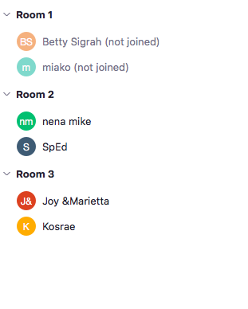

4.7. Pohnpei State Mini Summit Minutes

College of Micronesia – FSM
Minutes Reporting Form

Meeting Group: | Pohnpei Community Members – Online Summit 2020  Are We Living Up To Our Mission?

Date: | Time: | Location:
11/05/20 | 4:00 – 4:30pm | Zoom

Summary of Recommendations with Suggested Timeline & Responsibilities:
- Reconvene participants in this group for a follow up session – 4th week of January 2021.

Comments/Upcoming Meeting Date & Time/Etc.:
Tuesday January 26th 2021 – 3pm – 4:30pm Pohnpei time
Purpose / Question to be Answered (community members please make your suggestions):

Some ideas: How do we better engage the communities we serve?
…… your ideas here…

Agenda:
- Welcome
- Minute of silence
- Reading of COM-FSM Mission Statement
- Mission fulfillment indicators review
- Are we living up to our mission?
- So what? What next?

Agenda/Major Topics of Discussion:

Agenda:
- Welcome
About people had confirmed participation before the meeting, but on the day, two people joined in addition to CTEC Campus Dean and facilitator VPIEQA.

2. Minute of silence

- Reading of COM-FSM Mission Statement

The College of Micronesia-FSM is a learner-centered institution of higher education

that is committed to the success of the Federated States of Micronesia

by providing academic, career and technical educational programs characterized by continuous improvement and best practices.

- Mission fulfillment indicators review

Being a smaller group, while waiting for the possibility of more participants, VPIEQA shared the outputs of COM-FSM’s summits last year, in which a Strengths-Weaknesses-Opportunities-Challenges (SWOC) analysis was done by members of the college and community together.

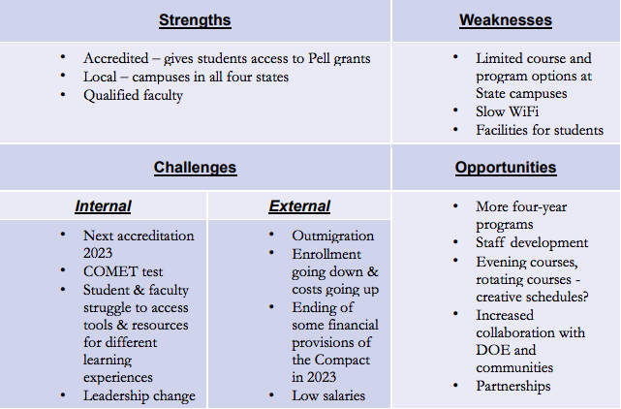
Reference Document: College of Micronesia-FSM 2019 Visioning Summit & Mini-Summit Reports

COM-FSM uses and shares data to determine how effectively it is accomplishing its mission. This data can be found at http://www.comfsm.fm/?q=Institutional_Set_Standards_and_Mission_Fulfillment_Indicators using a traffic light system: green = achieved, yellow = minimally achieved, red = not achieved

Participants worked together to consider the college mission statement and accompanying mission fulfillment indicators, which are divided into three.

- Part 1: “The College of Micronesia-FSM is a learner-centered institution of higher education.
- Part 2: “that is committed to the success of the Federated States of Micronesia”.
- Part 3: “by providing academic, career and technical educational programs characterized by continuous improvement and best practices”

The group considered the following three questions relating to the mission fulfillment indicators:

- How many indicators are there?
- How many are green (achieved), yellow (minimally achieved) or red (not achieved)?
- Discuss: Are we living up to our mission?

Participants decided to focus on those areas which were marked red (not achieved) or yellow (minimally achieved).

- Are we living up to our mission?

In total there are 24 mission fulfillment indicators. Of these, 17 are met (green), 4 are minimally achieved (yellow), and 3 are not achieved (red).

The following indicators are minimally achieved (yellow):
- Graduate Employment Rates: % of students that completed a CTE program and are employed in related field.
- Fall-to-spring persistence rate
- Fall-to-fall persistence rate
- Institution-wide Credit Grades % Completed

These 3 indicators are not achieved:
- Academic challenge benchmark
- Student faculty interaction
- Transfer rate

In particular, we noted the importance of student-faculty interaction. We have been using tools such as DropOut Detective, which can help flag students who are falling behind. Counseling services are then alerted and can work to find ways to best support the student.

Considering the transfer rate, we discussed that being an accredited institution helps our students transfer their credits to other institutions. Transfer depends on articulation agreements; 15 institutions of higher education are currently listed on COM-FSM’s articulation table, including Shepherd University (West Virginia) leading to a BA in Business Administration or Computer Information Science; Temple University (Japan campus) leading to a BA in Psychological Studies or BS in International Business; and Chaminade University (Honolulu) credit transfer to meet degree requirements.

We also considered persistence rate, what that means, and that if we focus on student-faculty interaction, can we expect this to help student engagement.

Importance of island culture, how we need to find ways to keep our students engaged and their active participation, otherwise, they may drop out more.

- So what? What next?

No particular recommendations were made – today was the first time working in this format, time and discussions were limited. Being few participants, we decided to provide a time and space to continue an open dialogue.

March and May will not be good times because of elections.

Comments/Upcoming Meeting Date & Time/Etc.:

Participants:
Titles/Representative | Name | Present | Absent
 | Lynn Narrhun
 | Lover Haimin
COM-FSM CTEC Campus Dean | Grilly Jack
COM-FSM VPIEQA | Caroline Kocel

Handouts/Documents Referenced:
http://www.comfsm.fm/?q=Institutional_Set_Standards_and_Mission_Fulfillment_Indicators

Articulation agreements between COM-FSM and other institutions of higher education

College of Micronesia-FSM 2019 Visioning Summit & Mini-Summit Reports

College Web Site Link:
www.comfsm.fm

Prepared by: | C. Kocel | Date Distributed: | 11/12/20

